What Does a CNN Actually Learn? Visualising Feature Maps in Image Classification

Introduction
The most successful deep learning architectures in image classification are Convolutional Neural Networks (CNNs). They find a lot of applications in various fields like facial recognition, medical image analysis, self-driving vehicles and quality inspection systems. Even though CNNs usually achieve good-classification accuracies, they are often considered black-boxes since it is difficult to understand how they arrive at their predictions.
The objective of this tutorial is to visualize the feature maps obtained from the convolutional layers of a CNN. Instead of classifying accuracy, we will see how CNNs convert input data from pixels to such meaningful value. In this section, we will train a CNN with the Fashion-MNIST dataset and look at the feature maps at various stages. This technique helps in understanding how deep learning models perceive image data.
By the end of this tutorial, you will understand how CNNs learn hierarchical visual features and why feature map visualisation is useful to interpret deep learning models.

Dataset Overview
The Fashion-MNIST dataset is a collection of grayscale images representing 10 categories of clothing items. Each image is 28 × 28 pixels and belongs to one of the following classes:
T-shirt/top, trouser, pullover, dress, coat, sandal, shirt, sneaker, bag, ankle boot.
Fashion-MNIST is frequently used as a replacement for the original MNIST handwritten digit dataset because it presents a more challenging image classification task.
Before training the CNN, the images were normalised to values between 0 and 1 and reshaped into a format suitable for convolutional layers.

Understanding the CNN Architecture
The CNN used in this tutorial consists of two convolutional layers followed by max-pooling operations and fully connected layers.
The architecture is:
Input Image Convolution Layer 1 Max Pooling Convolution Layer 2 Max Pooling Dense Layer Output Layer
First convolutional layer learns visual patterns or features like edges and textures. The second convolution layer takes the simple patterns and creates more abstract representations which will help to classify the input.
Question: Why not use a traditional neural network?
Traditional neural networks treat every pixel independently. CNNs preserve spatial relationships between pixels and therefore perform much better on image data.
Training the CNN
After preprocessing the dataset, we trained the CNN with the Adam optimiser and categorical cross-entropy loss function.
When training the model, the model learns to filter whatever analytical image structure is useful for the performance of a task. You don’t have to do any manual feature engineering unlike traditional machine learning.
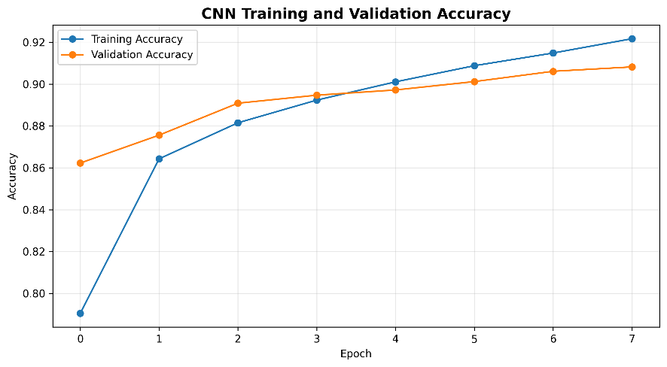
Figure 1: Training and Validation Accuracy
Training and validation accuracy keeps increasing with each epoch. Thus, the model is learning visual patterns useful for the task from the training data.
Question: What would happen if training accuracy increased while validation accuracy decreased?
This would indicate overfitting, meaning the model is memorising the training data rather than learning generalisable features.

Evaluating Classification Performance
Once training is complete, the model is evaluated using the test dataset.
Figure 2: Confusion Matrix
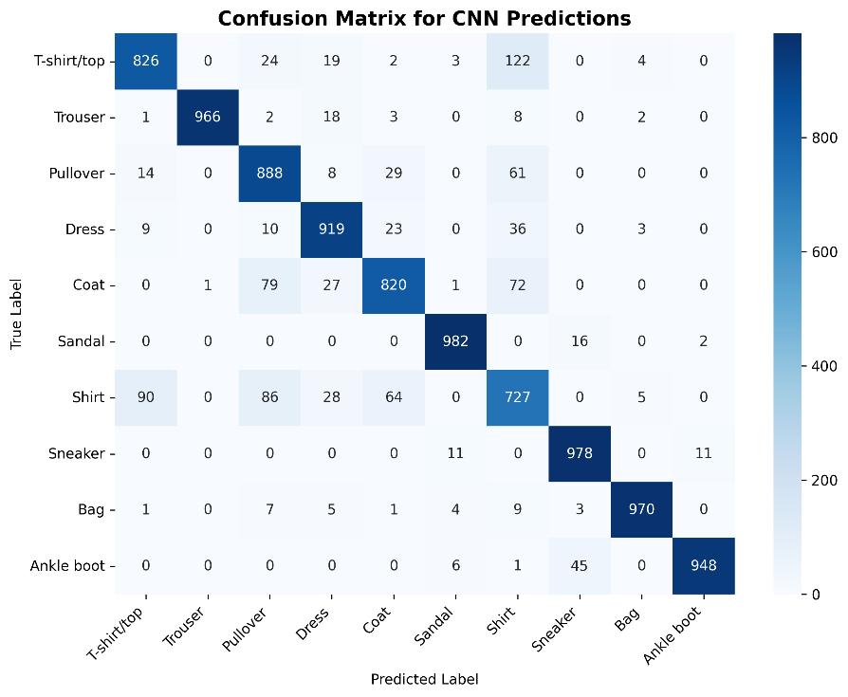
The confusion matrix shows the correct classifications and the categories that were mistaken.
The classification of many categories, especially sneakers and bags, goes very well because they have specific visual characteristics. On the contrary, it is likely that shirts, pullovers and coats will be confused, which justifies their inclusion in one class.

Question: Why is analysing mistakes important?
The incorrect predictions will help us understand the limitations of the model and also the additional training data and other architecture improvement required.

Visualising Feature Maps from the First Convolution Layer
To understand what the CNN learns, we examine feature maps produced by the first convolutional layer.
Figure 3: Feature Maps from the First Convolution Layer
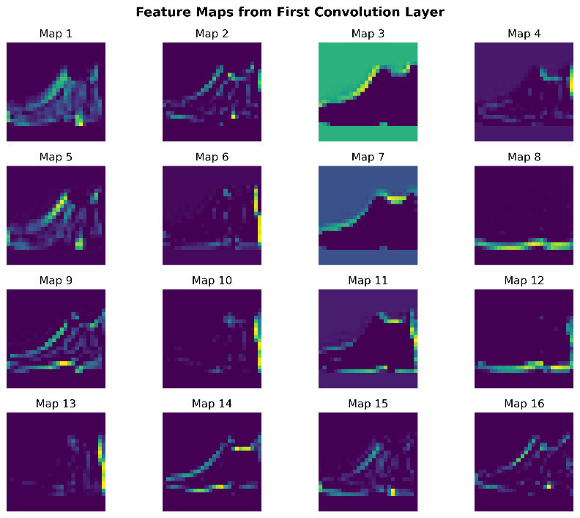
These visualisations demonstrate that the CNN does not process the entire image as one object. Instead, it decomposes the image into smaller visual components that can later be combined into more meaningful representations.
Question: Which feature maps appear to focus on the object's outline?
Look for maps where bright regions clearly correspond to the external shape of the clothing item.
The first convolutional layer behaves similarly to classical edge-detection filters used in image processing.

Visualising Feature Maps from the Second Convolution Layer
The second convolutional layer receives information from the first layer rather than directly from the image itself.
Figure 4: Feature Maps from the Second Convolution Layer
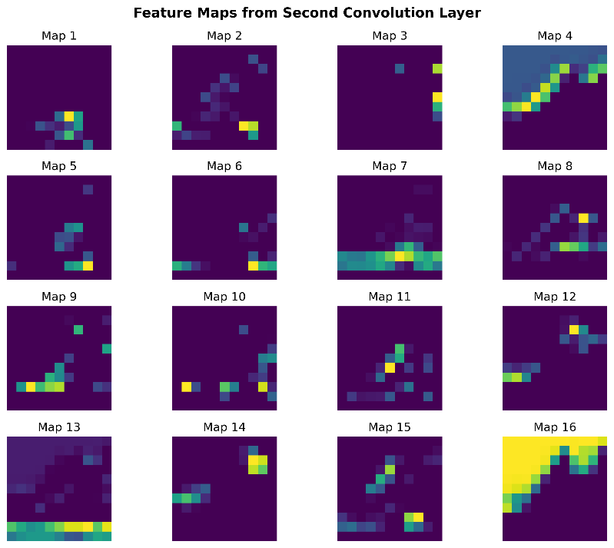
The feature maps from the second layer appear less recognisable than the first layer. In simpler terms, developing complex machinery requires the combined functioning of simpler components.
Question: Why are deeper feature maps harder to interpret?
The network is learning more abstract representations that are optimized for classification, not for humans.
One of the main reasons CNNs perform well on image classification tasks is because of this hierarchical feature learning system.

Analysing Correct Predictions
Figure 5: Correct Prediction Example
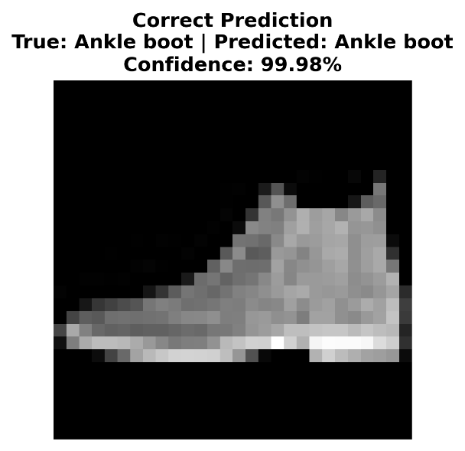
The object was predicted correctly and with high confidence by the model.
It’s often the case that correct prediction happens with an object that has visual characteristics that are distinct enough to differentiate it from others in the class.
Examples include.
- Bags.
- Sneakers.
- Sandals.

Analysing Incorrect Predictions
Figure 6: Incorrect Prediction Example
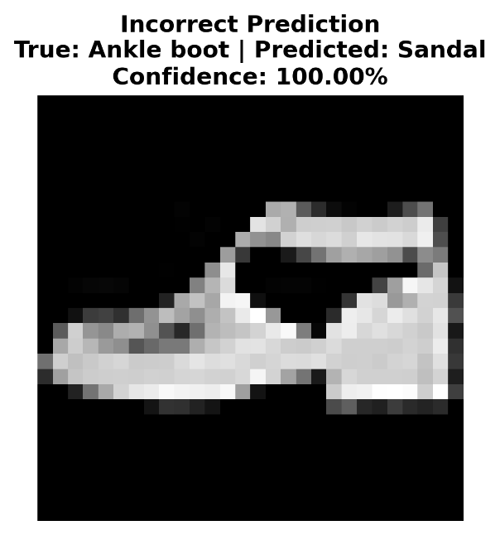
The model assigns the wrong class despite having relatively high confidence.
This highlights an important limitation of CNNs. Even when feature extraction is successful, visually similar classes can still cause confusion.
For example:
- Shirt vs Pullover
- Coat vs Shirt
- Dress vs Coat
Such mistakes are expected because these clothing categories often share overlapping visual characteristics.
Question: Does a high confidence score guarantee a correct prediction?
No. Sometimes neural networks are very confident and wrong. This is one reason model interpretation and error analysis remain important.

Discussion
The results reveal that CNNs learn to extract visual features hierarchically. The early convolutional layers learn the edges or simple structures and the deeper layers learn combinations of these structures and textures.
Feature map visualization shows that CNNs don’t memorize the training examples only. Rather, they create internal models to encode meaningful visual information.
Model behaviour cannot be easily characterised using model accuracy alone. The confusion matrix along with one or two misclassification examples are not good enough. It is possible for two models to be similarly accurate while relying on different representations.
It is worthwhile to visualize feature maps since they are a good way to understand how CNNs process the data of an image and why they perform classification on images so effectively.

Advantages and Limitations
Advantages:
- Automatically learns useful image features.
- No longer requires manual feature engineering
- It can do well with image classification tasks.
- Learns representations of visual information hierarchically.
Limitations:
- Requires substantial computational resources.
- Internal representations can still be difficult to interpret.
- Performance depends heavily on training data quality.
- Deep layers often become too abstract for direct human interpretation.

Ethical Considerations
CNNs are being used in increasingly high-impact domains including health, surveillance, and biometric identification. Although these systems yield positive efficiency and accuracy, they also lead to ethical issues.
Machine learning models may show bias towards certain groups over others. For instance, facial recognition systems can suffer from accuracy issues for unrepresented groups if trained on unbalanced datasets.
In addition, incorrect predictions may cause severe damage in certain applications such as medical diagnoses or security. The assessment of CNNs should factor in their fairness, transparency, and accountability, not solely their accuracy.
Feature map visualisation makes the model more transparent by giving an insight of what the model has learnt. However, it may not make it fully interpretable.

Conclusion
This tutorial explained how CNNs learn representations from images using the Fashion MNIST dataset. After training a CNN, the feature maps from two convolutional layers were visualised and studied.
The findings showed that lower layers mostly sense edges and textures, while higher layers learn more abstract visual concepts. Examples of correct and incorrect predictions further demonstrated the strengths and weaknesses of image classification using CNNs.
By comprehending these internal representations, we can gain insight into how deep learning models process image data, and as such, it can help reduce the perception of CNNs as completely black boxes.
Visualising feature maps can help practitioners understand better model behaviour and, ultimately, foster more confidence in the decisions deep learning systems.

References
LeCun, Y., Bottou, L., Bengio, Y., & Haffner, P. (1998). Gradient-based learning applied to document recognition. Proceedings of the IEEE, 86(11), 2278–2324.
Goodfellow, I., Bengio, Y., & Courville, A. (2016). Deep Learning. MIT Press.
Xiao, H., Rasul, K., & Vollgraf, R. (2017). Fashion-MNIST: A Novel Image Dataset for Benchmarking Machine Learning Algorithms. arXiv:1708.07747.
Chollet, F. (2021). Deep Learning with Python (2nd ed.). Manning Publications.
TensorFlow Developers. (2025). TensorFlow Keras Documentation. https://www.tensorflow.org/api_docs/python/tf/keras

